# Supply Chain Logistics Analytics

# Case let 1: Focus on Decision Making - Maxgood House Coffee

Maxgood House Coffee Company produces for variables of ground coffee, all of which are sold in 1-pound vacuum bags. These coffees are Jamaican, Peruvian, Colombian and Special Blend; the latter is a blend of Jamaican, Peruvian and Colombian beans. The Special Blend contains 25 percent Jamaican beans, 35 percent Peruvian beans and 40 percent Colombian beans. Currently, Maxgood can sell all of each type of coffee that it can produce, although its wholesales have specified that at least 25 percent of all coffee they buy must be the Special Blend. The table below shows the number of pounds of each type of bean that the Maxgood coffee buyers can obtain for the coming month and the price per pound.

Country of Origin Pounds available per Month Price per Pound

Jamaican 80,000 $ .50

Peruvian 94,000 $ .60

Colombian 1,30,000 $ .75

Maxgood sells its coffees to wholesalers at the following prices (per pound): Jamaican $1.50; Peruvian $ 1.65; Colombian $1.95 and Special Blend $1.80.

The company has the capacity to grind and package 400,000 pounds of coffee per month. Blending capacity is limited to 90,000 pounds per month. Maxgood has no loss of weight in either the grinding or blending processes; in other words, 1 pound of coffee beans yields 1 pound of ground coffee. Pre-printed vacuum bags cost $.04 each. Labor costs are estimated to be $.26 per pound for the non-blended coffees and $.41 per pound for the blended coffees.

Maxgood management is trying to decide how many pounds of each type of coffee to have the buyers purchase and how many pounds of each type of coffee they should produce and ship to their wholesalers. Maxgood's coffee buyers have also informed management that an additional 70,000 pounds of Colombian beans are available, but at a cost of $.95 per pound (a premium of $.20 per pound).

### Case let 2 -Transportation and Assignment: Focus on Decision Making

In July of each year, James Burner, Director of Public Works for the city of Metropolis, is faced with the unpleasant but necessary task of awarding private snow removal contracts for the coming winter. Metropolis is located in upstate New York and is subject to frequent and heavy snowfalls. The city's Public Works Department has sufficient equipment and employees to clear the major streets and highways within the city. The Department has found, however, that it is more practical to hire private contractors to clear side streets and some of the smaller public parking areas. In the past, this practice has sometimes proved to be a major headache for the city. When the private contractors fail to clear all the streets assigned to them on a timely basis, not only is traffic in that neighborhood disrupted, but the residents complain loudly to the mayor's office and the newspapers. This creates a major political "hot potato" putting a great deal of pressure on the Director of Public Works.

Each year, private contracts submit bids for snow removal in designated sectors of the city. Mr. Burner reviews these bids and then awards contracts. While city regulations do not limit his selection to the low bidder for each sector, his objective is to minimize the overall snow removal costs for all sectors. In reviewing the past performance of the various private contractors, Mr. Burner has come to the conclusion that many of the problems result not from inability or incompetence, but because contractors are over-committed. Contractors normally have few problems when the snowfall is average, but during some snowstorms their equipment is often insufficient to keep up with the load. To deal with this problem, Mr. Burner has decided to award most contractors just one sector. He feels Anderson's Snow Removal Service, the largest private contractor, has the capacity to clear up to three sectors.

*Data Preparation / Problem Formulation*

The city is currently divided into eight sectors. The Department of Public Works has received bids from twelve private contractors. Mr. Burner had placed all bids for each sector on a large blackboard in his office and was attempting, by trial-and-error, to evaluate the bids when his administrative assistant, Cathy Hogan, looked at the blackboard and said, "Oh, an assignment problem. I had to do one of these in my evening MBA class last semester. The computer sure makes short work of these, doesn't it? Mr. Burner responded, "It sure does. In fact, I was just about to have you work on this. Can you have a solution for me by this afternoon?" Cathy said, "Of course," and copied the following information from the board.

Sector

|  |  |  |  |  |  |  |  |  |
| --- | --- | --- | --- | --- | --- | --- | --- | --- |
| Contractor | 1 | 2 | 3 | 4 | 5 | 6 | 7 | 8 |
| Anderson | 41 | 36 | 32 | 53 | 34 | 51 | 43 | 47 |
| Snyder | 38 | 35 | 30 | 48 | 33 | 43 | 46 | 49 |
| Quinlin | 42 | 43 | 38 | 50 | 33 | 48 | 42 | 51 |
| Jackson | 43 | 41 | 33 | 49 | 41 | 53 | 43 | 48 |
| Colella | 44 | 37 | 35 | 56 | 39 | -- | -- | -- |
| Campbell | 43 | -- | -- | 47 | 40 | 41 | 37 | 45 |
| Sweeney | 39 | 40 | 36 | 52 | 32 | 49 | -- | -- |
| Murillo | 40 | 41 | 34 | 55 | 37 | 47 | 38 | 48 |
| Washington | -- | 37 | 37 | 51 | 35 | 52 | 38 | 51 |
| Gomes | 43 | 39 | 34 | 52 | 36 | 50 | 43 | 54 |
| Morgeiwcz | 38 | 36 | 33 | 47 | 31 | 45 | 39 | 46 |
| Franklin | 42 | 38 | 33 | 50 | 38 | 49 | 40 | -- |

(All figures are in thousands of dollars)

**Case let 3:**

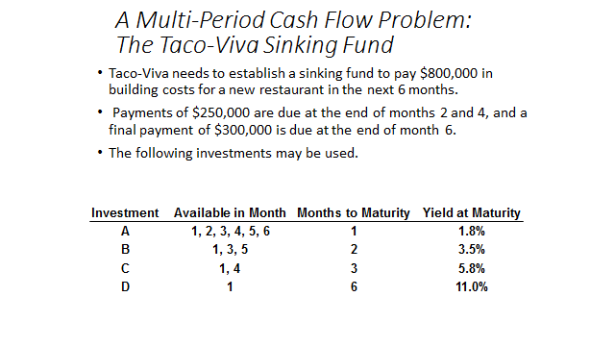

**Case let 4:**

